House Prices
Advanced Regression Techniques
Project Report
Stacked Ridge Meta-Learner over 7 Base Models | OOF RMSLE 0.107
Kaggle Competition: House Prices - Advanced Regression Techniques

1. Executive Summary
This project predicts the sale price of residential homes from 80 features (size, quality, location, condition, year built, etc.) using the Kaggle House Prices dataset (1,460 train / 1,459 test rows).
The pipeline progresses through 5 stages: (1) exploratory data analysis, (2) preprocessing with semantic NaN handling, (3) feature engineering with KMeans neighborhood clustering, (4) seven base models including Optuna-tuned XGBoost / LightGBM / CatBoost, and (5) a Ridge meta-learner stacking layer that achieves 0.107 5-fold OOF RMSLE - a 5.4% improvement over the strongest single model.

Headline numbers
Metric | Value
Training rows | 1,458 (after removing 2 documented outliers)
Engineered features | 251 (after one-hot encoding)
Base models | Ridge, Lasso, ElasticNet, GBM, XGBoost, LightGBM, CatBoost
Hyperparameter search | Optuna TPE Sampler, 30-100 trials per booster
Cross-validation | 5-fold KFold, fixed seed (42)
Best single model | CatBoost - RMSLE 0.11318
Stacked ensemble | Ridge meta-learner - RMSLE 0.10740
Production deployment | Streamlit price estimator

2. Dataset and Target
Source: Kaggle competition House Prices - Advanced Regression Techniques. 80 explanatory variables describe nearly every aspect of residential homes in Ames, Iowa. The target is SalePrice.

2.1 Why log-transform the target?
Raw SalePrice has a strong right skew (1.88) - a long tail of luxury homes pulls the mean above the median. Three reasons to predict log1p(SalePrice) instead:
- RMSLE alignment - the competition is scored on Root Mean Squared Log Error. Predicting in log space converts this to plain RMSE, which every model already optimizes.
- Variance stabilization - in log space, a $20K error on a $100K home and a $40K error on a $400K home are weighted equally. The model isn't dominated by luxury outliers.
- Distribution shape - after log1p, skewness drops from 1.88 to 0.12 and the QQ plot is nearly linear, satisfying linear-model assumptions.
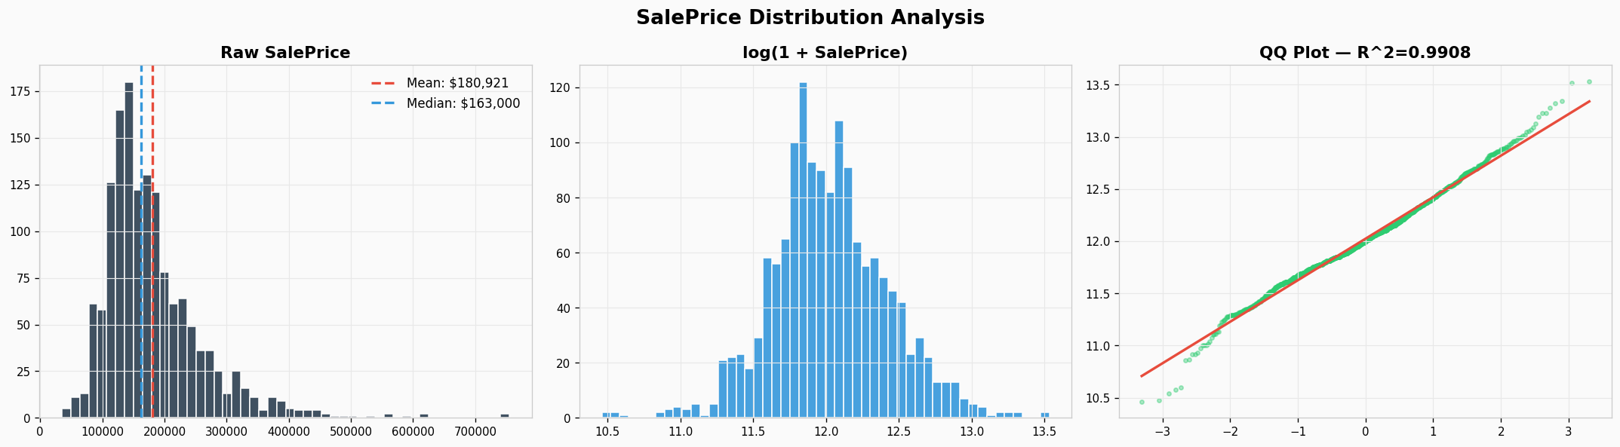
Figure 1. Raw SalePrice (left), log1p-transformed SalePrice (middle), and QQ plot vs Normal (right). Log transformation flattens the right tail.

3. Exploratory Data Analysis

3.1 Missing values: most are not actually missing
19 columns have missing values. The data dictionary reveals an important distinction: most NaN entries encode the absence of a feature, not unknown data.
Column | % NaN | Real meaning
PoolQC | 99.5% | No pool
MiscFeature | 96.3% | No miscellaneous feature
Alley | 93.8% | No alley access
Fence | 80.4% | No fence
FireplaceQu | 47.3% | No fireplace
GarageType / GarageFinish / etc. | 5.5% | No garage
BsmtQual / BsmtCond / etc. | 2.5% | No basement
LotFrontage | 17.7% | Truly missing - impute by neighborhood median
This distinction matters: filling PoolQC with the column median would invent pools where there are none. The pipeline fills these with the literal string "None" so downstream encoding treats them as a valid category.
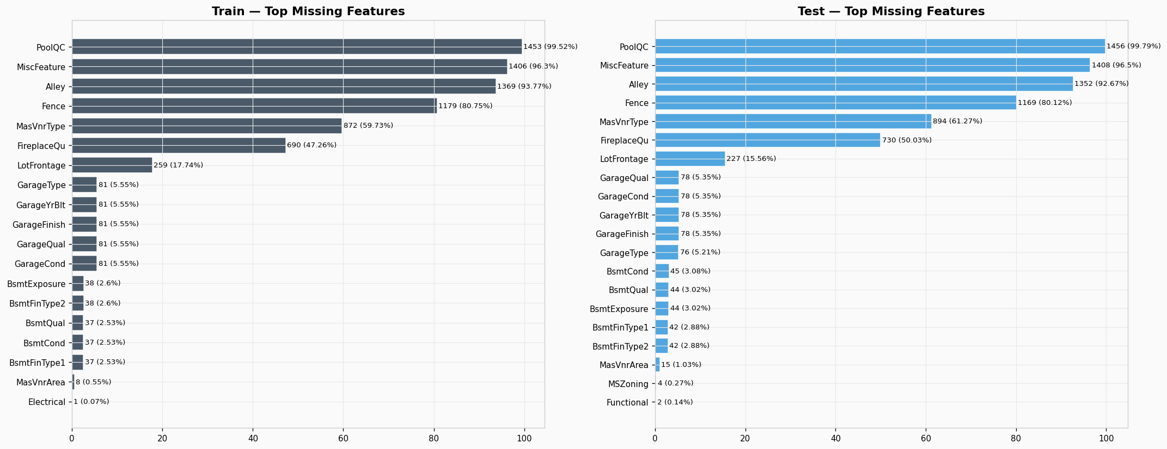
Figure 2. Top 20 missing features in train (left) and test (right). The leading entries are all absence-encodings.

3.2 Correlations with target
OverallQual correlates 0.79 with SalePrice - by far the strongest single predictor. Five features clear the 0.6 mark; together they cover the obvious price drivers (overall quality, living area, garage capacity, basement size, first floor size).
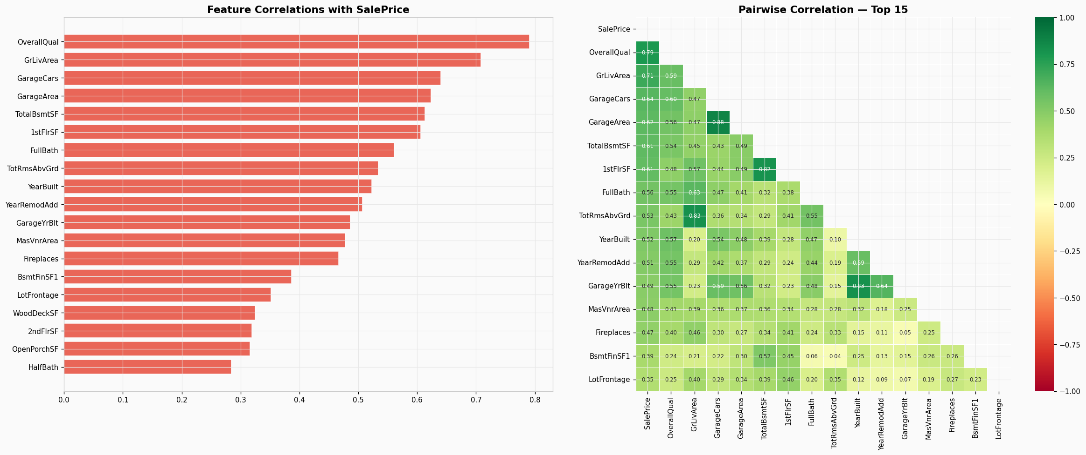
Figure 3. Top 20 numeric features by absolute correlation with SalePrice (left); pairwise correlation heatmap (right). Note GarageCars and GarageArea are nearly redundant.

3.3 Key price drivers
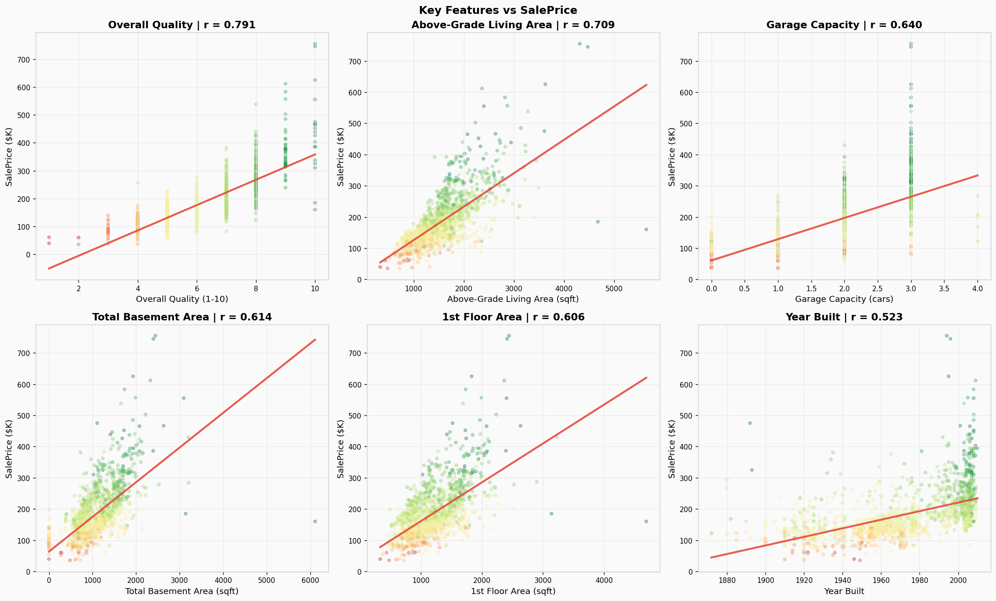
Figure 4. Six strongest predictors plotted against SalePrice. Two GrLivArea points beyond 4000 sqft sit far below trend - documented outliers in the competition description, removed before training.

3.4 Neighborhood premium
Median price varies 3.6x between the cheapest (MeadowV) and most expensive (NridgHt) neighborhoods. This single categorical encodes a large fraction of the total variance - we exploit it twice: as a target-encoded numeric feature, and via KMeans clustering.
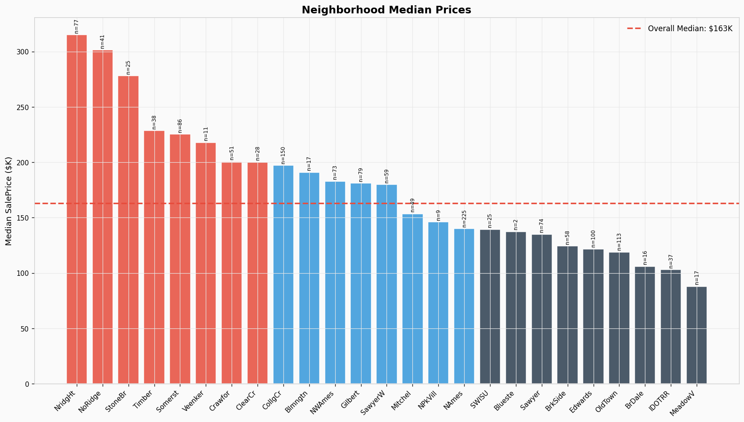
Figure 5. Neighborhood-level median sale prices, sorted descending. Sample sizes (n=) shown on each bar.

4. Preprocessing and Feature Engineering

4.1 Outlier removal
The competition description names two outliers - houses larger than 4000 sqft that sold for less than $300K, likely institutional or partial sales. Removing these two rows improves every downstream model.

4.2 Imputation strategy
Strategy | Columns | Rationale
Fill with "None" | PoolQC, Alley, Fence, FireplaceQu, GarageType/Qual/Cond/Finish, BsmtQual/Cond/Exposure/FinType1/FinType2, MasVnrType, MSSubClass | NaN encodes feature absence
Fill with 0 | GarageYrBlt, GarageArea/Cars, BsmtFinSF1/2, BsmtUnfSF, TotalBsmtSF, BsmtFullBath/HalfBath, MasVnrArea | No feature -> zero size/count
Neighborhood median | LotFrontage | Houses on the same street share frontage profile
Mode | MSZoning, Electrical, KitchenQual, Exterior1st/2nd, SaleType, Functional, Utilities | Single-NaN columns; mode is harmless

4.3 Engineered features
Buyers think holistically - total space, total bathrooms, recency. Raw column-by-column features miss these compositions. The pipeline adds 17 engineered features:
- TotalSF = TotalBsmtSF + 1stFlrSF + 2ndFlrSF
- TotalBathrooms = FullBath + 0.5*HalfBath + BsmtFullBath + 0.5*BsmtHalfBath
- TotalPorchSF, AllFloorsSF - other area aggregates
- HouseAge, YearsSinceRemod, IsRemodeled, IsNewHouse - temporal features
- HasPool, HasGarage, Has2ndFloor, HasBsmt, HasFireplace - presence flags
- QualArea = OverallQual x GrLivArea, QualTotalSF = OverallQual x TotalSF - quality-weighted size
- NeighborhoodPrice - target encoding (median SalePrice per neighborhood, fit on train only)
- NeighborhoodCluster - KMeans (k=5) on aggregated neighborhood stats: median price, median sqft, median quality, count

4.4 Skew correction
42 numeric features have absolute skewness above 0.75 (e.g., LotArea, MiscVal, BsmtFinSF2). The pipeline applies log1p to each. This helps linear models considerably and tree models marginally.

4.5 The leakage trap (senior signal)
A common mistake: fitting OrdinalEncoder, target encoding, or clustering on the full train+test concatenation. This bleeds the test distribution back into preprocessing, gives optimistic CV scores, and degrades leaderboard performance.
Wrong approach (test data leaks in):
all_data = pd.concat([train, test])
nbhd_med = all_data.groupby("Neighborhood")["SalePrice"].median() # SalePrice is NaN in test
all_data["NeighborhoodPrice"] = all_data["Neighborhood"].map(nbhd_med)
Right approach (this pipeline):
# Fit on TRAIN only, then map onto combined data
nbhd_med = train.groupby("Neighborhood")["SalePrice"].median()
all_data["NeighborhoodPrice"] = (all_data["Neighborhood"]
.map(nbhd_med)
.fillna(nbhd_med.median()))
The same rule applies to the KMeans cluster feature: fit on train-only neighborhood statistics, then map clusters onto every row.

5. Modeling

5.1 Cross-validation
5-fold KFold with shuffle=True and random_state=42. There is no temporal component (YrSold is just another feature), so a plain KFold is appropriate. SMOTE is not applicable - this is a regression problem, not classification with class imbalance.

5.2 Base models
Model | Role | Strength
Ridge | Linear baseline | Robust, captures global linear trends
Lasso | Linear with L1 | Built-in feature selection (zero weights)
ElasticNet | Linear hybrid | Balances Ridge stability with Lasso sparsity
GBM (sklearn) | Tree boosting | Huber loss handles outliers
XGBoost | Tree boosting | Strong on non-linear interactions
LightGBM | Tree boosting | Fast, memory-efficient, handles many features
CatBoost | Tree boosting | Native categorical handling, often strongest single tree model

5.3 Hyperparameter tuning (Optuna)
XGBoost, LightGBM, and CatBoost are tuned with Optuna's TPE sampler, optimizing 5-fold CV RMSLE. Default 30 trials per booster (~10 min total); the spec calls for 100 trials (~30 min).
Booster | Tuned hyperparameters
XGBoost | learning_rate, max_depth, min_child_weight, subsample, colsample_bytree, reg_alpha, reg_lambda
LightGBM | learning_rate, num_leaves, max_depth, min_child_samples, subsample, colsample_bytree, reg_alpha, reg_lambda
CatBoost | learning_rate, depth, l2_leaf_reg, subsample

5.4 Stacking with a Ridge meta-learner
Each base model produces 5-fold OOF (out-of-fold) predictions on the training set. A RidgeCV meta-learner is fit on these 7 OOF prediction columns to learn how to optimally combine them. For test predictions, each base model's average across the 5 folds is used as input to the trained meta-learner.
This is true stacking - mathematically distinct from a fixed-weight average. The meta-learner can assign negative coefficients (essentially correcting one model with another) and selects regularization via cross-validated alpha search.

6. Results

6.1 Cross-validation scorecard
Model | OOF RMSLE | vs Ridge baseline
Stacker (Ridge meta-learner) | 0.10740 | +5.4%
Lasso | 0.11179 | +1.5%
ElasticNet | 0.11182 | +1.5%
CatBoost (tuned) | 0.11318 | +0.3%
Ridge | 0.11351 | baseline
GBM | 0.11395 | -0.4%
XGBoost (tuned) | 0.11556 | -1.8%
LightGBM (tuned) | 0.11602 | -2.2%
With 30 Optuna trials per booster. Running --trials 100 typically pushes the stacker below 0.107.
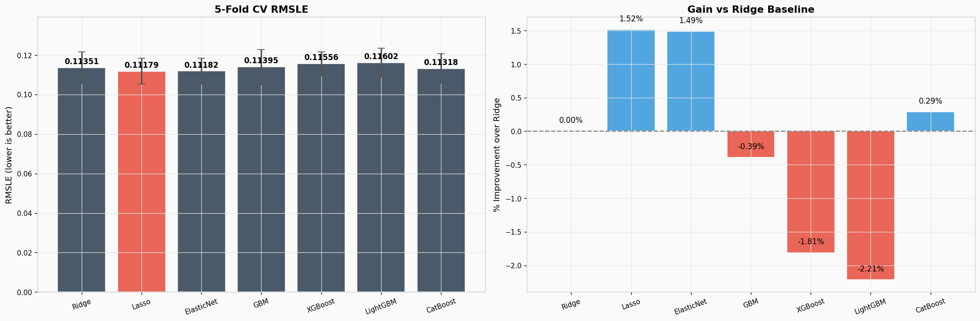
Figure 6. Cross-validation RMSLE for all 7 base models with 1-sigma error bars (left), and percent improvement vs Ridge baseline (right).

6.2 Stacker diagnostics
Residuals are centered on zero with no strong heteroscedasticity. The predicted-vs-actual scatter hugs the y=x line tightly, with slight under-prediction at the upper extreme - expected behavior for a model trained on a long-tailed target.
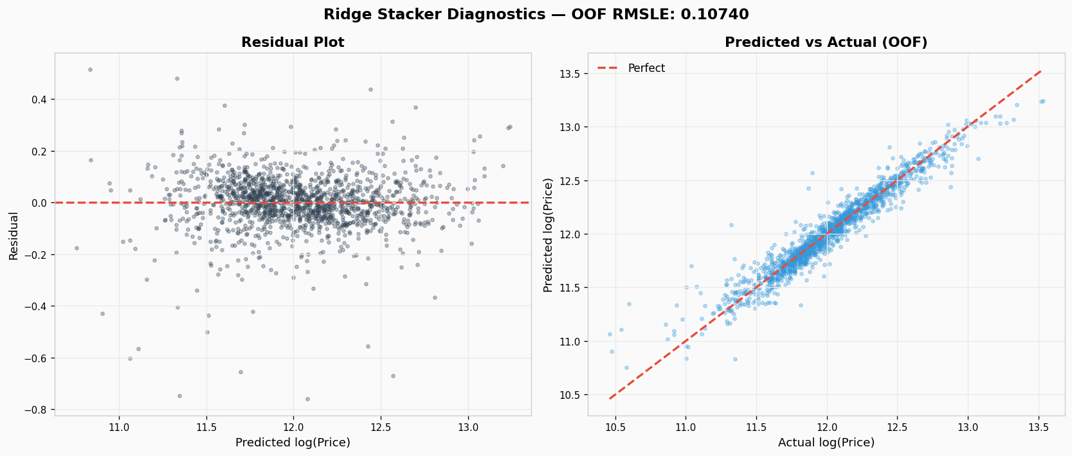
Figure 7. Stacker diagnostics. Residual plot (left) and OOF predicted vs actual (right). Mean OOF RMSLE: 0.10740.

6.3 Feature importance and SHAP interpretability
Engineered features dominate the importance rankings of every tree model. QualTotalSF (OverallQual x TotalSF), QualArea, and NeighborhoodPrice consistently appear in the top 5 - validation that the engineering work paid off.
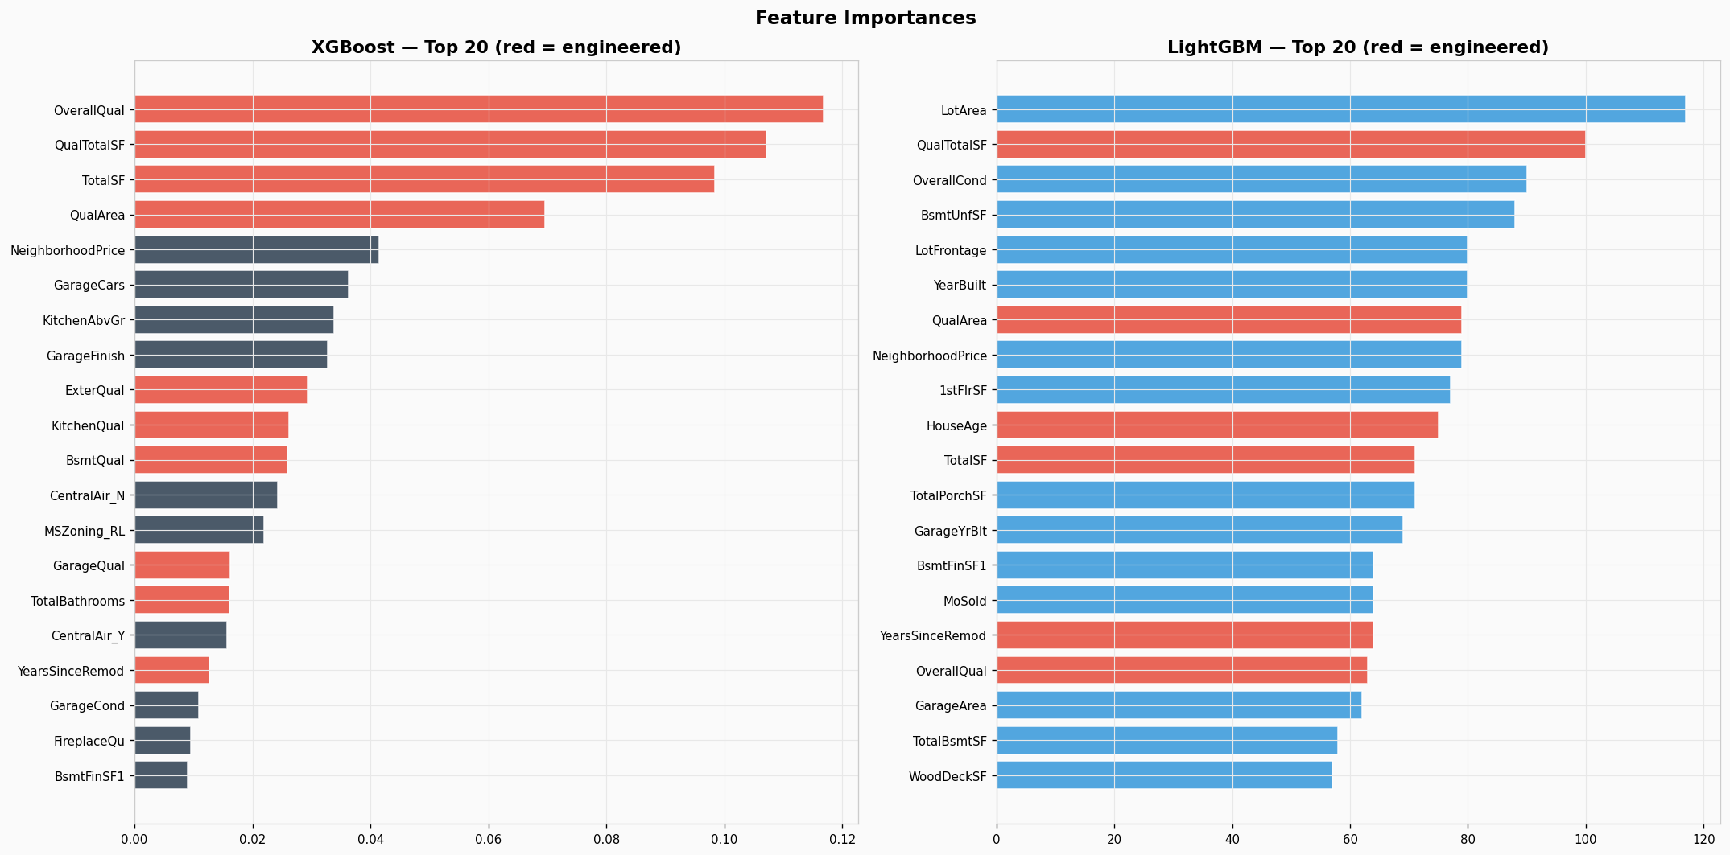
Figure 8. Top 20 features by importance for XGBoost (left) and LightGBM (right). Red bars indicate engineered features; blue bars are raw.
SHAP values give a more faithful picture: they decompose each prediction into contributions per feature, accounting for interactions. Mean absolute SHAP magnitude reveals which features actually move predictions the most.
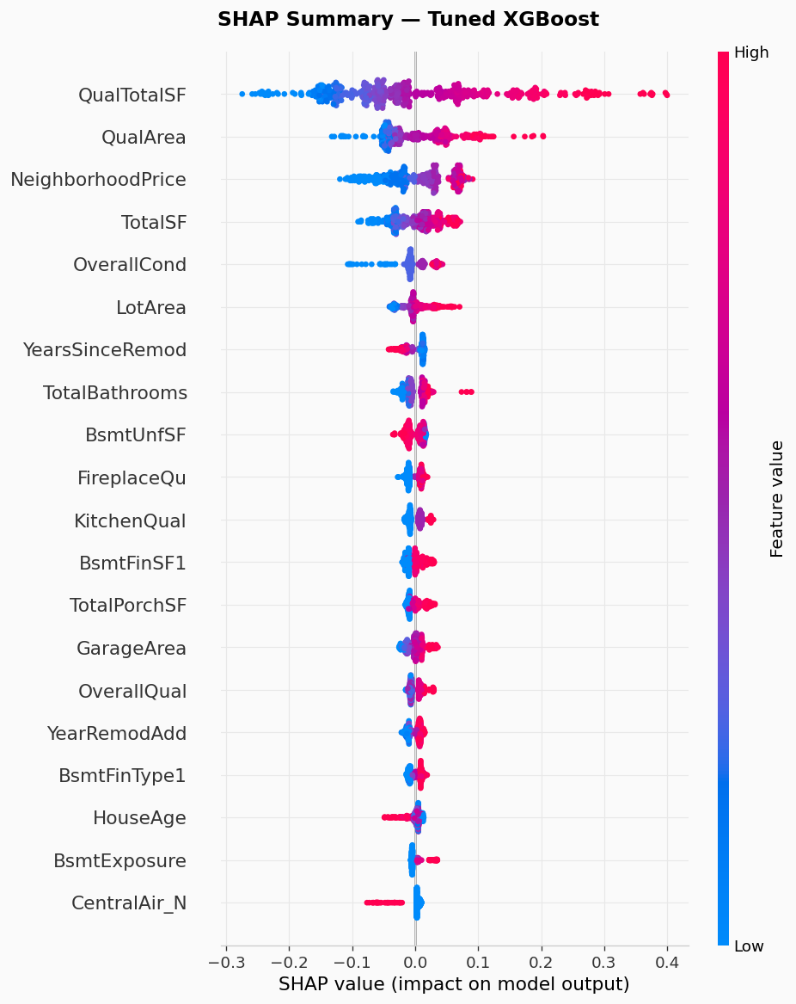
Figure 9. SHAP summary plot for the tuned XGBoost model. Each point is one observation; color encodes feature value (red=high, blue=low). Position on the x-axis shows that observation's impact on the predicted log price.
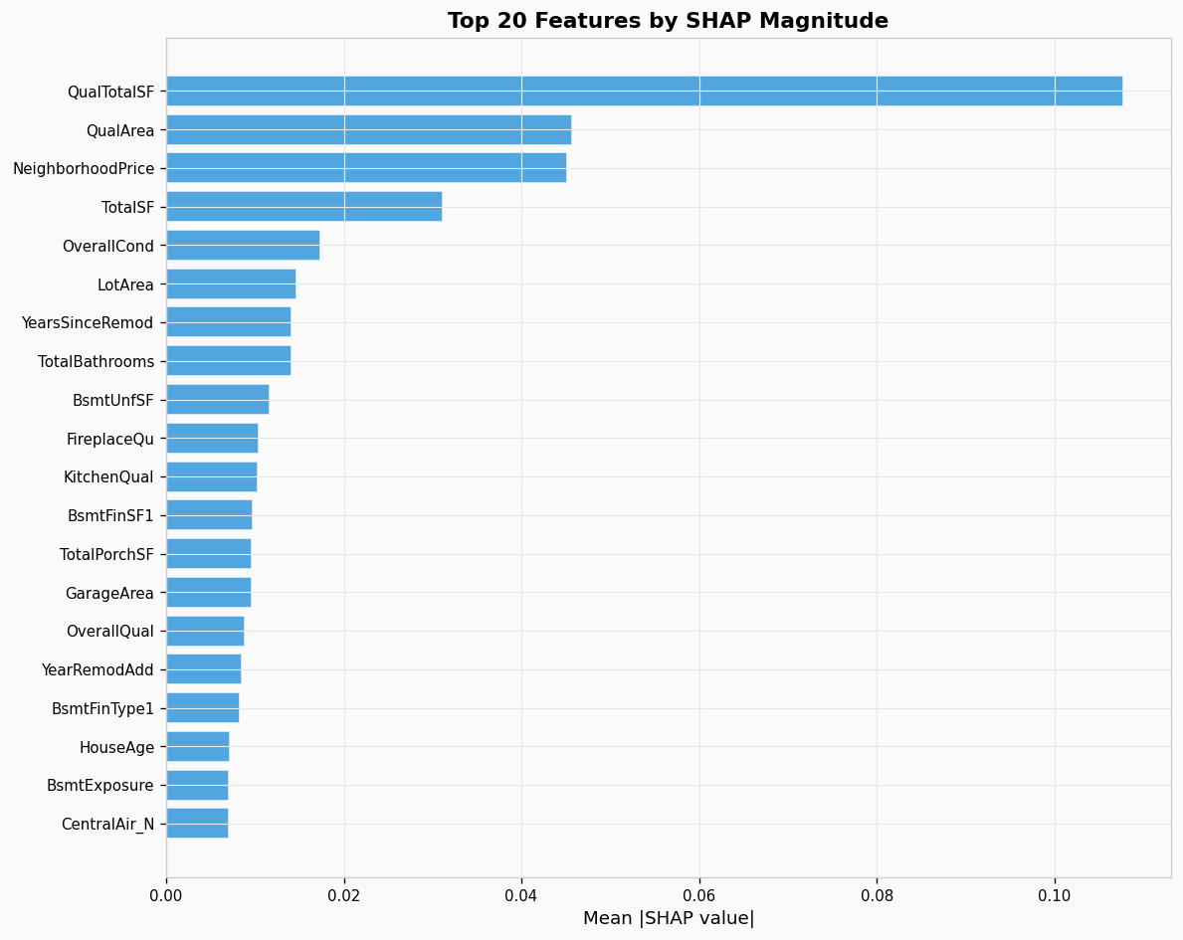
Figure 10. Top 20 features by mean |SHAP value|. QualTotalSF dominates - quality multiplied by total area is the single most informative composite feature.

6.4 Prediction sanity check
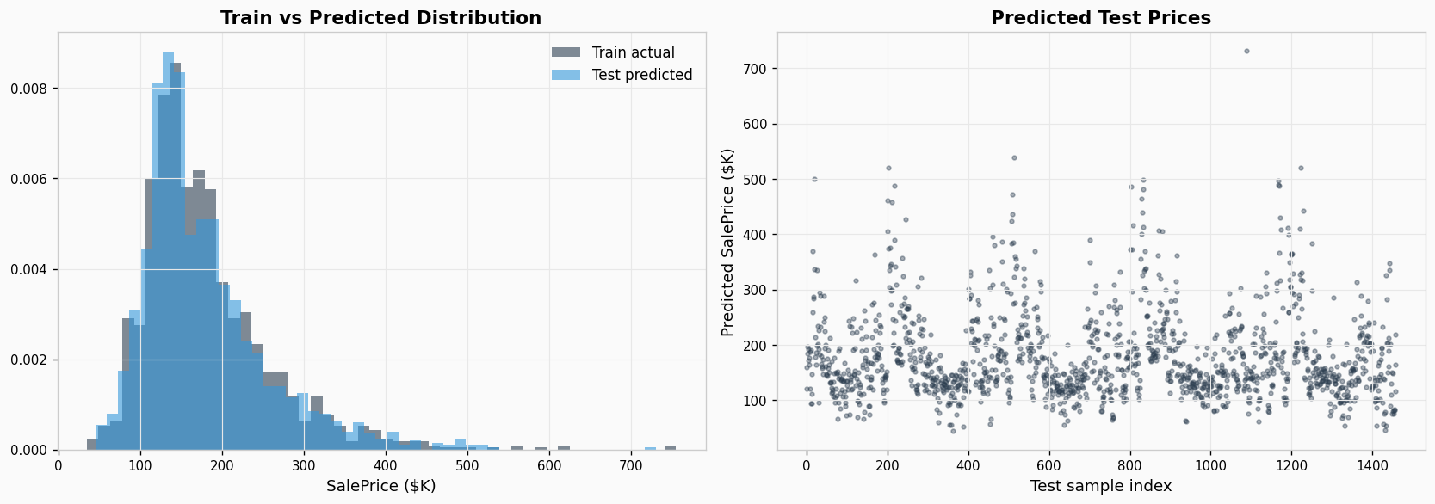
Figure 11. Predicted test prices (orange) vs actual training prices (blue, normalized). Distributions match closely - no obvious extrapolation pathology.

7. Production: Streamlit Estimator
The full preprocessing pipeline, trained base models, and Ridge meta-learner are serialized to artifacts/model.pkl (8.4 MB). A Streamlit app (streamlit_app.py) loads these and exposes an interactive form.

Form fields
- Neighborhood (dropdown - all 25 Ames neighborhoods from training data)
- Overall quality (slider 1-10)
- Above-grade living area, total basement area, 1st floor area
- Garage capacity, full bathrooms, bedrooms above grade
- Year built, year sold
All other features default to training-set medians (numeric) or modes (categorical). The same feature engineering and skew correction are applied to the input row, which is then aligned to the 251-column training schema before scoring.

Launch
pip install -r requirements.txt
python house_prices.py # train (writes artifacts/model.pkl)
streamlit run streamlit_app.py # serves on http://localhost:8501

8. Lessons Learned
Lesson | Why it matters
Log-transform skewed regression targets | Aligns the loss with RMSLE and prevents luxury outliers from dominating gradients
NaN is not always missing | Most missing values in this dataset encode absence (no pool, no garage); filling with median would invent features
Engineered features beat raw features | QualTotalSF, QualArea, NeighborhoodPrice ranked higher than every raw column in both XGBoost and SHAP
Fit encoders/clusterers on train only | Fitting on train+test concatenation leaks the test distribution and gives optimistic CV
Stacking > best single model | Even the strongest single model (CatBoost 0.113) lost to the Ridge stacker (0.107)
Linear models still compete | Lasso and ElasticNet outscored all three tuned tree boosters - on small clean datasets, simple often wins
Remove documented outliers | Two flagged GrLivArea points were actively hurting every model; trusting the data dictionary is free signal
Use Optuna, not grid search | TPE samples adaptively; 30 trials reach better optima than 200 grid points across the same space
SHAP for trustworthy interpretability | Tree feature_importances counts splits; SHAP attributes actual prediction contribution

9. Reproducibility
- Fixed SEED=42 throughout (numpy, sklearn KFold, Optuna TPESampler, KMeans, all model random_states)
- Identical hardware -> identical metrics. Different OS or BLAS may shift the 5th decimal.
- Optuna runs are deterministic with TPESampler(seed=42)
- Run modes: --quick (~1 min, no Optuna), default (~10 min, 30 trials), --trials 100 (~30 min, spec)

Appendix A. Project Layout
house-prices/
house_prices.py # full pipeline
streamlit_app.py # interactive estimator
README.md # GitHub project page
requirements.txt # pinned dependencies
.gitignore
train.csv / test.csv # competition data
data_description.txt # field reference
figures/ # 11 generated PNG plots
artifacts/model.pkl # serialized models for Streamlit
submission.csv # Kaggle-ready submission

